**Project Car Share**

**Software Requirements Specification**

**80594, Fall, 2018**

**Modification history:**

|  |  |  |  |
| --- | --- | --- | --- |
| Version | Date | Who | Comment |
| v1.0 | 10/4/18 | Gage Kettering | Starting Document |
| v1.1 | 10/9/18 | Gage Kettering | Finishing up first copy |

**Team Name:** Zwischen

**Team Members:**

* Gage Kettering | [gdkettering2062@eagle.fgcu.edu](mailto:gdkettering2062@eagle.fgcu.edu) | github.com/cluckheads
* Brandon Davis | [btdavis3378@eagle.fgcu.edu](mailto:btdavis3378@eagle.fgcu.edu) | github.com/btdavis3378
* Tyler Marlow | [tjmarlow5889@eagle.fgcu.edu](mailto:tjmarlow5889@eagle.fgcu.edu) | github.com/tmarlow98
* Charles Taylor | [cftaylor7218@eagle.fgcu.edu](mailto:cftaylor7218@eagle.fgcu.edu) | github.com/chuckt95
* Zachary Greening | [zjgreening3328@eagle.fgcu.edu](mailto:zjgreening3328@eagle.fgcu.edu) | github.com/zgreening

**Contents of this Document**

Introduction

* Software to be Produced
* Definition, Acronyms, and Abbreviations

Product Overview

* Assumptions
* Use Case Diagram
* Use Case Descriptions

Specific Requirements

**SECTION 1: Introduction**

Software to be Produced:

The software to be produced will be a total of 10 windows that will all have their own features. The windows will have the capability of communicating with one another depending on the user who is signed in. The riders will have different permissions than the drivers.

Definitions, Acronyms, and Abbreviations:

* None

**SECTION 2:** **Product Overview**

Assumptions:

* This project is a desktop app that will allow for easy carpooling. The riders will communicate with the drivers and vice versa.

Use Case Diagram:

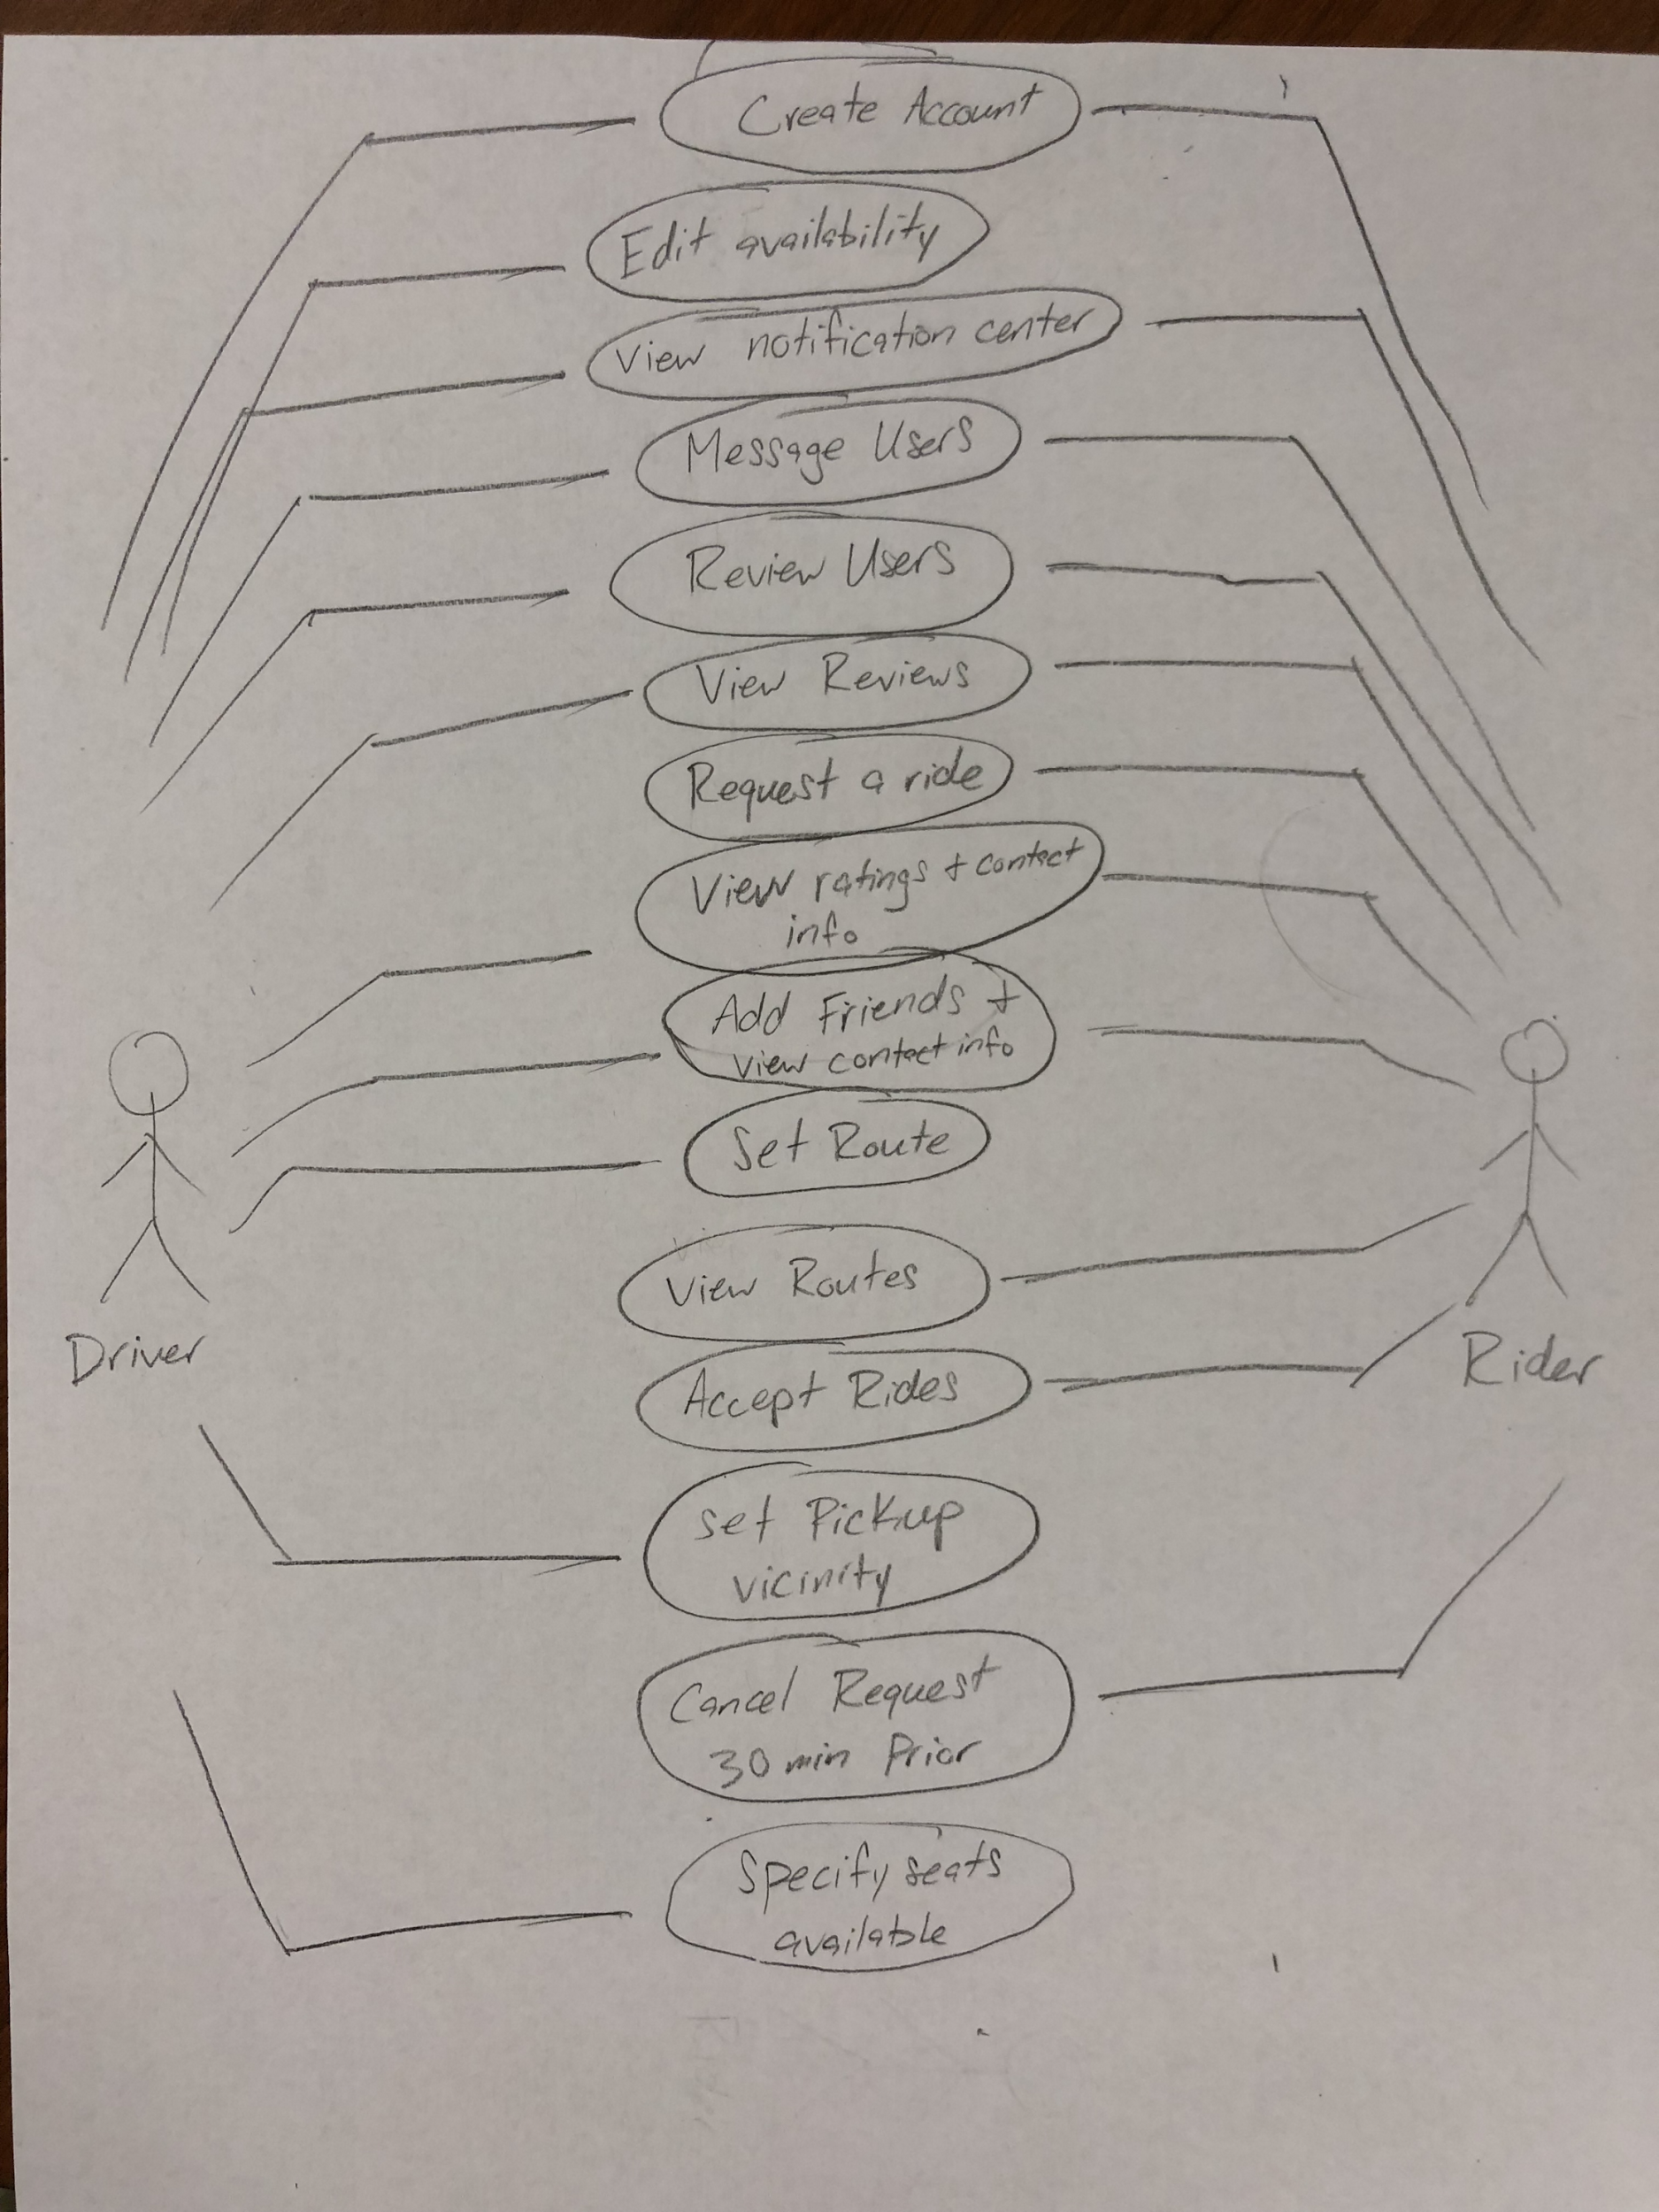

Use Case Descriptions:

* **Create Account** : Users are able to create a new account. Users will have the ability to create either a driver account or a rider account.
* **Edit Availability** : The driver user has the capability to edit their availability as a driver to fit their schedule. If a driver is set as unavailable they will not receive notifications and will not be seen by riders.
* **View Notification Center :** Both users will have the ability to view the notification center. The notification center will notify a driver if a rider has requested a ride, as well as notify a rider when the driver has accepted the rider.
* **Message Users :** Both users will have the ability to message. The messaging center will be a place for drivers and riders to specify where to pick up as well as speak to one another before commiting to the ride.
* **Review Users :** A rider will have the ability to rate their driver on a scale of 1-5, based on how they drive and the overall atmosphere. The driver will also have the same ability based on how the rider acts and other characteristics.
* **View Reviews :** Both users are able to view reviews of their driver and if they are riding with other riders. The driver can view the riders ratings before accepting them as a rider.
* **Request a Ride :** The rider is able to request a rider from any drivers that have set their availability as open. The driver will then have the ability to accept the rider or not, but not be able to request a rider.
* **View Ratings and Contact Info :** All users have the ability to friend other users and then view their ratings and contact information. Friends will be able to contact one another on or off the app depending on what they set as their contact preference.
* **Add Friends and View Contact Info :** Users will have the ability to add other users to a friends list. Once users are friends, viewing contact information will become available. In addition, friends will be able to send messages to other friends.
* **Set Route :** Drivers will have the ability to create and set a route to their destination. Drivers will also be able to edit the route to the destination.
* **View Routes :** Riders will be able to view the routes set by drivers. The user can also select which date to view the routes. The user can decide which route is most accommodating to their location and destination.
* **Accept Rides :** Once a rider has chosen a route to a destination set by a driver, the user can accept that route. Once a ride is accepted, a confirmation notification will be sent to both the driver and rider.
* **Set Pickup Vicinity :** The driver will be able to select a vicinity along the route. If a user is within the vicinity, then the driver can meet and pickup the rider.
* **Cancel Request :** The rider will have the ability to cancel a ride request. The cancel request must be at least 30 minutes prior to the pickup. If a ride request is canceled, a notification will be sent to the driver informing them of the cancellation.
* **Specify Seat Availability :** The driver will have the ability to set how many seats are available in their vehicle. In addition, vehicle description can be set by the driver.

**SECTION 3: Specific Requirements**

**< The following template must be used for each requirement; you should have about 15 requirements total: >**

|  |
| --- |
| **No:** 1 |
| **Statement:** The system shall allow user to create a driver account |
| **No:** 2 |
| **Statement:** The system shall allow the user to create a rider class |
| **No:** 3 |
| **Statement:** The system shall allow “driver” accounts to edit their status, available or not available, which affects whether they are visible to “rider” accounts. |
| **No:** 4 |
| **Statement:** The system shall have a notification system for when a driver arrives, ride is on the way, and ride is accepted |
| **No:** 5 |
| **Statement:** The system shall have a messaging system between riders and drives. |
| **No:** 7 |
| **Statement:** The system shall allow riders to review their drivers |
| **No:** 8 |
| **Statement:** The system shall allow drivers to review their riders |
| **No:** 9 |
| **Statement:** The system shall allow riders to request a ride with specific drivers |
| **No:** 10 |
| **Statement:** The system shall allow users to modify their account |
| **No:** 12 |
| **Statement:** The system shall allow users to view other users’ profiles for ratings |
| **No:** 13 |
| **Statement:** The system shall allow for users to add other users’ as friends |
| **No:** 14 |
| **Statement:** The system shall allow for users to view their “friends” contact information |
| **No:** 15 |
| **Statement:** The system shall remove the riders request for a driver when a driver accepts the rider. |
| **No:** 16 |
| **Statement:** The system shall allow drivers to set their route for riders to view |
| **No:** 17 |
| **Statement:** The system shall allow riders to view routes and accept rides |
|  |
| **No:** 18 |
| **Statement:** The system shall allow for drivers to set their pickup vicinity |
| **No:** 19 |
| **Statement:** The system shall allow riders to cancel their request 30 minutes before the driver is set to leave |
| **No:** 20 |
| **Statement:** The system shall allow for drivers to specify amount of seats available. |
| **No:** 21 |
| **Statement:** The system shall allow users to view other users’ reviews |

|  |
| --- |
| **No:** 22 |
| **Statement:** The system should use Google Maps |

Template created by G. Walton ([GWalton@mail.ucf.edu](mailto:GWalton@mail.ucf.edu)) on Aug 30, 1999 and last updated Aug 15, 2000; updated by A. Koufakou, Aug 2014

This page last modified by Gage Kettering on Oct. 09, 2018